EXERCISE 11
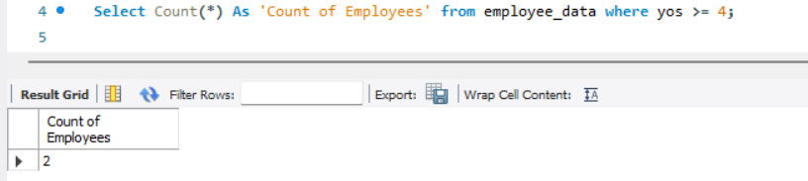
- Count the number of employees who have been with Bignet for four or more years.

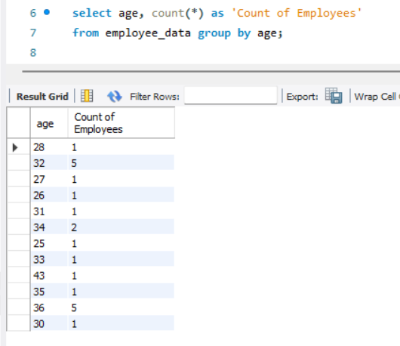
- Count employees based on their ages.

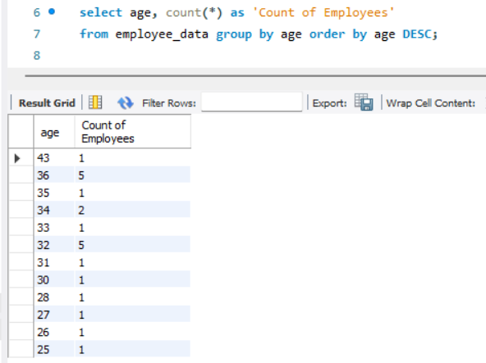
- Modify the above so that the ages are listed in a descending order.

- Find the average age of employees in different departments (titles).
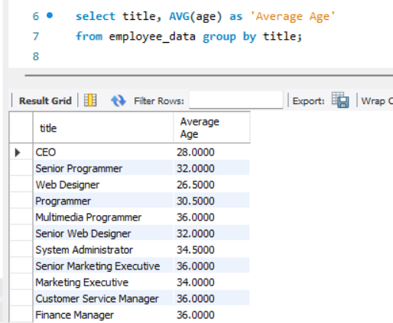

- Change the above statement so that the data is displayed in descending order of average ages.
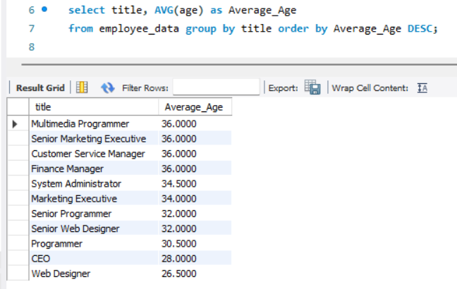

- Find and list the percentage perk (perk/salary X 100) for each employee with the % perks sorted in a descending order.
